SHELL SCRIPT

HARIRAJ G

230701104

BASIC CALCULATOR

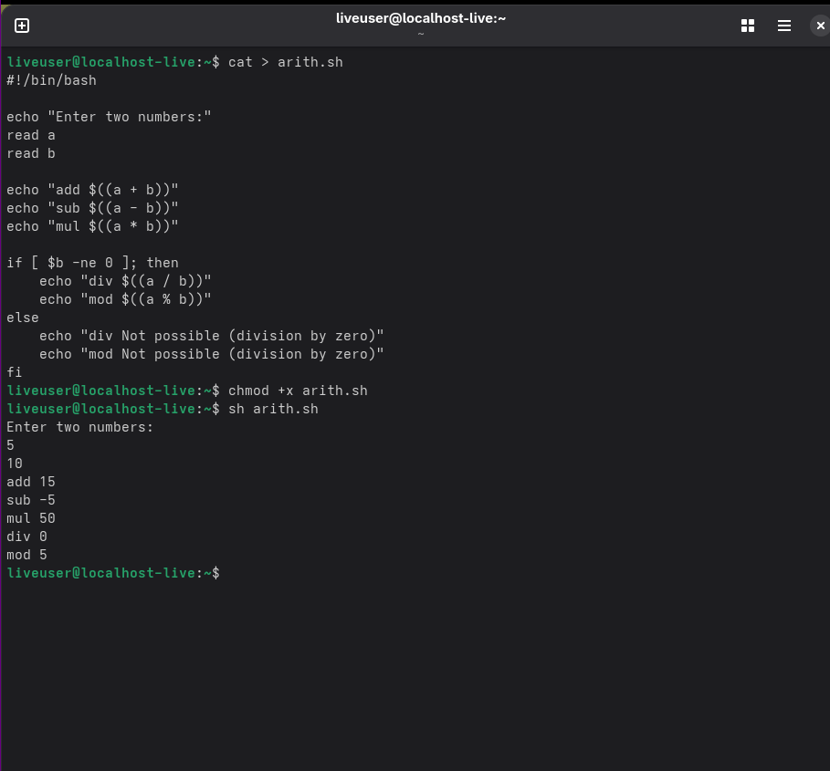

LEAP YEAR

